CSC443 Assignment 1

3.1

System Block Size: 4096 bytes

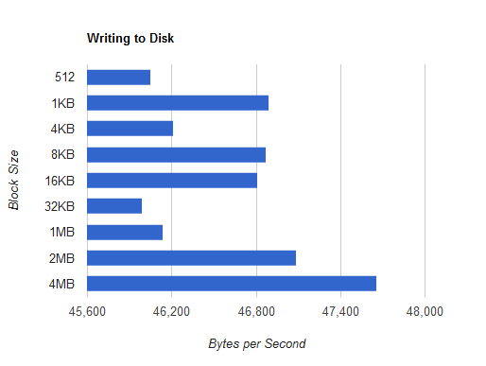

According to the results gathered through the tests, it appears as though the optimal block size is 2MB. All the results before 2MB fluctuate greatly, while both 2MB and 4MB seem to fluctuate at a higher rate on average. Increasing the block size will not contribute to greater performance because the buffer write size and the time to perform writes on the disk have equalized causing no bottleneck in the operation.

Writing Lines Speed: 35565 Bytes per Second

Between writing to a file line by line, and writing to a file in blocks, there is a substantial difference. As it turns out, writing to a file in blocks rather than line by line is much quicker. The speeds recorded appeared to show a minimum of 10000 bytes per second faster rates for writing in blocks than writing line by line. This is because writing to a buffer allows more efficient use of the disk’s read and write operations. Due to the filesystem running on a block size of 4KB, it would only be effective to write in multiples of such block size. Meanwhile, writing line by line causes the overhead of performing I/O actions to bottleneck the system rather than the processing time.

3.2

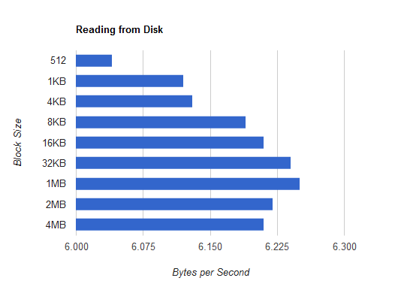

RAM Read Speed: 3517298 bytes per second

The ratio of sequential read rate between disk and RAM is ${10}^{6.18}:{10}^{6.55}$ where the ratio discussed in class was ${10}^{7}:{10}^{10}$ (10GB/s : 100MB/s).